Effectiveness of Online Interactive Tutorials on
Learning about Cranial Nerves
At the Pennsylvania State University College of Medicine

Emily M. Kowalik
Sponsor: Dr. Loren A. Evey

MSR Final Draft
March 2, 2008
Abstract
Current teaching modalities for the Structural Basis of Medical Practice course at the Pennsylvania State University College of Medicine include performing dissections, reading textbooks, studying atlases, and attending didactic lectures. Research has shown, however, that while none of these tools are optimal for students trying to learn areas of the body that are highly complex, “computer-aided learning” (CAL) is. We designed a study to compare the effectiveness of two styles of CAL in teaching a complex area of anatomy: cranial nerves. The participants—fifty-two volunteers from the class enrolled in human gross anatomy—were randomized to taking one of two online interactive tutorials on Glossopharyngeal Nerve anatomy and functional components (one containing only static images and, the other, only animated). The effectiveness of the tutorials was assessed objectively by comparing pretest and posttest scores between the two groups and subjectively by comparing post-tutorial survey results between the two groups. Effectiveness was also compared in groups created based on additional measures. Test scores indicated that both the animated and static tutorials had a statisctically significant effect on students’ learning (though there was no significant difference between the two), and that they were most effective in students reporting the most difficulty in learning anatomy. Comparing survey results of those completing the different tutorials indicated no statistically significant difference in students’ subjective assessment of tutorial effectiveness, with one exception; those completing the static tutorial rated theirs as slightly more efficient. These results will guide the development of the online interactive cranial nerve tutorials for all twelve of the cranial nerves.
Introduction
Lilienfield and Broering (1) report that human anatomy is one of the “parents of medicine.” In fact, medical students at the Pennsylvania State University College of Medicine are required to take Structural Basis of Medical Practice (which is Human Gross Anatomy) as their first class. Anatomy provides foundational knowledge for understanding diseases and learning how to preform physical examinations. Thus, physicians need to have a lasting knowledge of this subject. Just how do educators confer this knowledge to their students? Medical students learn human gross anatomy best by performing and studying dissections (2). Other tools traditionally used to teach this material include textbooks, atlases, slides, and didactic lectures. As Sinav and Ambron have observed, however, none of these tools are optimal for students trying to learn areas of the body that are highly complex (3). The anatomy and functional components of cranial nerves fall into this category. Since the 1960s, a new tool for medical education called “computer-aided instruction” (CAI) or “computer-aided learning” (CAL) has been evolving—most of which has been developed in response to students’ request for help with learning difficult material (4).
Many studies have reported the positive effect of CALon enhancing student learning in various medical school courses (1, 5, 6, 7, 8, 9, 10). Stanford et al. evaluated the effectiveness of CAL in teaching cardiac anatomy to a group of first-year medical students (5). By comparing the post-test scores of these students, they found that those who dissected and then completed the computer program outperformed those who only did either the dissection or the computer program. Hallgren et al. looked at the effectiveness of Web-based CAL on learning anatomical landmarks by first-year medical students enrolled in gross anatomy (6). Students who activated the Web-based material did significantly better on anatomic landmark exams than those who did not activate the material. In a more extensive study, Devitt and Palmer compared the effectiveness of three different versions of CAL on teaching liver and biliary tree physiology to second-year medical students (7). The three versions, in order of decreasing levels of visual content and interactivity, were: standard problem solving, free text, and didactic. In comparing post-test results, students who received the material through the free text or standard problem solving versions did no better than the control group. The students who received the didactic version (similar in structure to a lecture), however, performed significantly better than the other groups. These results conflict with other studies which show that increasing levels of visual content and interactivity are beneficial to the learning process (3, 11).
More studies need to be done to evaluate the effectiveness of this tool, CAL. In a search of the CAL literature that relates to medical education, Adler and Johnson found that 60% of all studies are of the “demonstration type,” i.e. they describe but do not evaluate the helpfulness of CAL (4). Only 11% of studies are “media-comparative,” which compare CAL with either traditional teaching methods or other CAL applications. In their conclusion, they suggest that current research should be “media-comparative” and focus specifically on comparing different CAL approaches with each other.
In 2005, Pennsylvania State University College of Medicine graudate, Amy Bridgeman, presented the results of her research comparing different CAL styles at the MSR Symposium. In comparing the effectiveness of an all text tutorial to an animated tutorial, she found the latter to be superior to the former (12). In response to her study, students requested more computerized tutorials, praising how enjoyable her tutorial made learning, how well it complemented lecture and dissecting, and how easy the technology was to use.
We designed a study to further compare the effectiveness of two approaches of CAL in teaching cranial nerve anatomy and functional components—this time analyzing the effect of the types of images presented. The key objectives of this study are: (1) to evaluate the effectiveness of two online interactive tutorials—one that contains only static images and one that contains only animated images—in learning about cranial nerve IX, the Glossopharyngeal Nerve; (2) to determine student's satisfaction with and perceived benefit of the online tutorials; and (3) to use the data obained to guide the development of other online tutorials for Human Gross Anatomy and other courses offered to students at the Pennsylvania State University as well as other institutions.

Method
Materials
Two interactive tutorials on the anatomy and functional components of cranial nerve IX, the Glossopharyngeal Nerve, were developed. One contained all static images (referred to as the Static Tutorial) and one contained all animated images (referred to as the Animated Tutorial). The tutorials presented the same content, which included the following: an overview of cranial nerves and the types of functional components they contain, a description of the gross anatomy of the Glossopharyngeal Nerve, and a thorough summary of the functional components of the Glossopharyngeal Nerve (see Figures 1-4 for screen shots of each of these content areas, respectively). Both tutorials were designed using Adobe Illustrator 10 (to draw all images) and Macromedia Flash MX Version 6.0 (to animate all images and create the tutorial interface).
A paper-and-pencil pretest consisting of sixteen multiple-choice questions was written to assess students’ baseline level of knowledge of the anatomy and functional components of the Glossopharyngeal Nerve. Two subjective questions were also asked to assess students’ subjective ability to learn anatomy and subjective view of their class ranking. A posttest consisting of thirty multiple-choice questions was written to assess students’ knowledge gain. The original sixteen questions from the pretest were repeated in the posttest; thus, the students were presented with fourteen new questions. A survey consisting of ten questionnaire items was written to assess students’ satisfaction with and perceived benefit of CAL. The questionnaire items were written in a 1-5 Likert format from strongly disagree to strongly agree. In a “comments” section, students were also given the opportunity to provide any additional comments they wished regarding the tutorial.
Participants
The participants were fifty-two medical and graduate students enrolled in Human Gross Anatomy during the fall 2007 semester. Students were recruited to join the study through a verbal announcement made during Anatomy class. Compensation for participation was provided in the opportunity study volunteers had in working through the tutorial before their peers in preparation for their class examination. Participation was not a class requirement or extra-credit activity. Approximately 30% of the class volunteered. No personal information was collected to identify the students.

Procedures
The study was conducted during the fourth and final “block” of Human Gross Anatomy. It is during this block that students cover head and neck anatomy, including cranial nerve anatomy and functional components. Participants could choose between three sessions, held over the span of a week, in which to take the tutorial. The first session was held a week after the fourth block began, and the last session, two weeks after.
The study was conducted in the George T. Harrell Library. Participants brought their personal laptops to work through the tutorial, as the computers in the Hershey Medical Center do not support Flash Player. As participants arrived, they were randomly assigned to either the Animated Tutorial or the Static Tutorial. Participants first completed the pretest. They then logged on to the Human Gross Anatomy website (http://www.humangrossanatomy.com), and the study PI entered her password to give them access to the password-protected tutorials. Participants then completed the tutorial to which they had been randomly assigned. Participants took forty-five to ninety minutes to complete their respective tutorials, although no time limit was applied. They then completed the post-tutorial survey. At the time of the study, participants were asked to create a four-figure combination of letters and numbers—that only they would know—to use to link their pretest, posttest, and survey to each other.

Results
The data collected from each study participant were five objective numbers and twelve subjective values. The objective numbers consisted of the following: pretest score (out of sixteen multiple-choice questions), repeated score (out of the sixteen pretest questions repeated on the posttest), improvement score (repeated score minus pretest score), posttest score (out of thirty multiple-choice questions), and time when they took the tutorial (relative to the start of the fourth and final “block” of Human Gross Anatomy). The subjective values consisted of participants’ assessment of the following: their difficulty in learning anatomy (four-point scale), their class rank (four-point scale), and whatever tutorial they just completed (ten questions with a five-point scale).
To evaluate the effectiveness of each tutorial, a paired two-sample t-test was run where the “pairs” were a participant’s pretest score and repeated score. Participants completing the animated tutorial improved by an average of 3.19 points, and those completing the static tutorial, by an average of 3.12 points (see Table 1). This was a statistically significant improvement for both the animated group (p<<0.001) and the static group (p<<0.001) (see Tables 2 and 3, respectively). Thus both tutorials were very effective in teaching students about Glossopharyngeal Nerve anatomy and functional components.
The next part of the analysis was to compare the effectiveness of both tutorials. The static group had a higher objective pre-tutorial knowledge base (pretest mean 12.31 or 76.9%) than the animated group (pretest mean 12.04 or 75.2%) and maintained that lead on analysis of their post-tutorial knowledge base (posttest mean 28.31 or 94.4%, and 27.65 or 92.2%, respectively) (see Table 1 and Figure 5). Using a two-sample t-test, however, to compare pretest, repeated, improvement, and posttest scores between the two groups showed no statistically significant difference (see Table 4). This demonstrated that neither the animated tutorial nor the static tutorial was superior as a teaching tool.
The next part of the analysis was to compare the effectiveness of the tutorials in different groups of participants based on various objective and subjective measures. Participants were first divided into three groups based on the time when they took the tutorial relative to the start of the fourth and final “block” of Human Gross Anatomy. Students completing the tutorials after 1 week of exposure to similar material in class had the worst mean scores (pretest 10.92, repeated 14.85, posttest 26.77), while those after 2 weeks had the best mean scores (pretest 12.74, repeated 15.65, posttest 28.68) (see Table 5 and Figure 6). An anaylsis of variance was run with each test score as the dependent variable and time of taking the tutorials as the independent variable. The analysis indicated that the time of taking the tutorials had a statistically significant effect on pretest, repeated, and posttest scores (F=5.173, p<0.01; F=6.018, p<0.01; F=4.936, p=0.01, respectively) (see Table 6). The margin of difference between posttest scores is smaller than between pretest scores, suggesting that either the 1-week group benefited more from the tutorials or that there was a ceiling effect on the posttest (limiting the 2-week group from showing further improvement).
Participants were then divided into eight groups based on pretest score to compare the effectiveness of the tutorials in those with varying objective pre-tutorial knowledge bases. Those with the worst pretest scores (7 and 9) had the lowest mean posttest scores (25). Those with the highest pretest scores (14 and 15) had the highest mean posttest scores (29.2 and 29.0, respectively). Students with the worst pretest scores (7 and 9) had the greatest mean improvement scores (7 and 5, respectively), and with each increase in pretest score there was a stepwise decrease in mean improvement score (see Table 7). An anaylsis of variance was run with repeated, improvement, and posttest scores as the dependent variables and pretest score as the independent variable. The analysis indicated that a participant’s pretest score (i.e. objective pre-tutorial knowledge base) had a statistically significant effect on their repeated, improvement, and posttest scores (F=2.256, p<0.05; F=26.799, p<<0.001; F=2.945, p=0.01, respectively) (see Table 8). This suggests that either the tutorials were more effective in those with a poor knowledge base or that, again, a ceiling effect on the posttest limited the high knowledge base group from showing further improvement.
Participants were then divided into five groups based on their reported pre-tutorial subjective knowledge to analyze the effectiveness of the tutorials in those with varying subjective knowledge bases. A majority of students (63%) strongly disagreed or disagreed with the statement, “Before I took the tutorial I was already knowledgeable on the Glossopharyngeal Nerve’s anatomy and its functional components.” Those who reported having the poorest knowledge base truly did (pretest mean 10.85) compared with those reporting the best knowledge base (pretest mean 13) (see Table 9). The poorest knowledge base group had the highest improvement score (mean 3.92), which was statistically significant when an anaylsis of variance was run with each test score as the dependent variable and subjective knowledge base as the independent variable (F=5.412, p<0.05) (see Table 10). Similar to the results based on objective data (although not as conclusive), this suggests that the tutorial is more effective in those with a poor subjective knowledge base.
Participants were also divided into four groups based on their reported subjective difficulty in learning anatomy concepts. A majority of students (52%) identified with the statement that mastering information in anatomy is, “Somewhat challenging with lots of effort,” which was the third of four levels of difficulty described. The group that reported having the most difficulty had among the worst pretest scores (mean 10.83); however, they had the highest mean repeated scores (15.67), improvement scores (4.83), and posttest scores (15.67) (see Table 11 and Figure 7). An anaylsis of variance was run with each test score as the dependent variable and learning difficulty as the independent variable. The analysis indicated that a participant’s difficulty in learning anatomy concepts had a statistically significant effect on the repeated and improvement scores (F=5.173, p=0.01; F=4.936, p<0.05, respectively) (see Table 12). Thus the tutorials were most effective in the students who report the most difficulty in learning anatomy concepts.
Participants were also divided into four groups based on their reported subjective class rank. Those who reported being in the lowest 1/3 of the class did score the lowest on the pretest (mean 11.25) compared with those reporting being in the top 1/3 (pretest mean 12.39) (see Table 13). An anaylsis of variance was run with each test score as the dependent variable and class rank as the independent variable. The analysis indicated a statistically significant difference between the group reporting being in the middle 1/3 of the class and all other participants on their repeated score (F=2.869, p<0.05) (see Table 14). Because this difference was small and only significant on the repeated score, it was deemed to be inconsequential.
Participants were then divided into four groups based on their level of preference for learning cranial nerve anatomy from another modality, i.e. textbook. A majority of students (65%) strongly disagreed or disagreed with the statement, “I would prefer to learn this material from a textbook.” Test scores were evenly distrubuted throughout all levels of preference (see Table 15). An anaylsis of variance was run with each test score as the dependent variable and level of preference for textbook as the independent variable. The analysis indicated no statistically significant effect of preference to learn from a textbook on pretest, repeated, improvement, or posttest scores (see Table 16). This suggests that a student’s preference to learn from a textbook has no effect on the effectiveness of either tutorial in teaching.
Participants were then divided into five groups based on their level of preference for learning cranial nerve anatomy from another modality, i.e. lecture. Test scores were evenly distrubuted throughout all levels of preference (see Table 17). An anaylsis of variance was run with each test score as the dependent variable and level of preference for lecture as the independent variable. The analysis indicated no statistically significant effect of preference to learn from a lecture on pretest, repeated, improvement, or posttest scores (see Table 18). This suggests that a student’s preference to learn from a lecture has no effect on the effectiveness of either tutorial in teaching.
To compare the Likert format survey results of those completing the animated versus static tutorials, the Mann Whitney U test was run on each question. The test indicated no statistically significant difference in students’ subjective assessment of the tutorial, with one exception; those completing the static tutorial rated theirs as slightly more efficient (U Statistic=450.5, p<0.05) (see Table 19). The difference was small; the average response from the static group was 4.77 and, from the animated group, 4.42 (where the Likert format response of “5” meant the participant strongly agreed with the statement, “This tutorial provides an efficient means to learn the material”). Though there was no statistical significance between the two groups, 96% of students from both groups thought their tutorial was helpful in learning, 94% thought their tutorial helped them answer questions on the posttest, 87% thought their tutorial was less stressful than other means of learning, 96% thought their tutorial was an enjoyable way to learn the material, 98% would recommend their tutorial to other students, and 100% would like online access to their tutorial. These results demonstrated a very positive and beneficial learning experience for participants completing either the animated or static tutorial.

Discussion
The results of this study suggest that both approaches of CAL—i.e. the Animated and Static tutorials—are very effective teaching tools for medical and graduate students learning about Glossopharyngeal Nerve anatomy and functional components. The added visual content provided by the Animated tutorial did not provide a significant difference in effectiveness (either objectively or subjectively). Furthermore, very positive comments were received from students taking either tutorial (see the Appendix). This suggests that the static images provided sufficient visual stimulus to solidify a student’s understanding of a difficult concept. This also suggests that less time can be spent on creating complex animations when designing other interactive tutorials on cranial nerve anatomy and functional components.
This study looked at other factors contributing to the effectiveness of the tutorials. The results suggest that the tutorials are more beneficial: (1) when taken early in the course of a teaching block, (2) in students who have a poor objective pre-tutorial knowledge base, and (3) in students who report the most subjective difficulty in learning anatomy concepts. This latter result is consistent with a study performed by Qayumi et al. which demostrated that CAL was the most effective in “low-achieving” students (13). It is also consistent with information presented in a review article by Schittek et al., which shows that CAL allows “poorer students to catch up” to stronger students (14). The results of this study also suggest that the tutorials’ benefit is not affected by a student’s: (1) subjective class rank, (2) preference to learn the material from textbook, or (3) preference to learn the material from lecture.
Practically speaking, these results provide some important concepts for implementing the cranial nerve tutorials into the Human Gross Anatomy course at the Pennsylvania State University College of Medicine. The tutorials can be offered to all medical and graduate students enrolled in the class, however, two specific groups of individuals should be encouraged to complete them. The first group includes those who report having significant difficulty in learning anatomy concepts. The second group includes those who have a poor knowledge base of the subject at hand. To identify those in this latter group, a pretest could be given a week after the fourth block has started. Those scoring below, say, 75% should be encouraged to complete the tutorials. All students should be informed of the following: the tutorials are most beneficial when completed earlier on during the block, their perceived class rank has no affect on the tutorials benefit, and their usual preference to learn from textbook or lecture has no affect on the tutorials benefit.
Many students made comments requesting similar tutorials for all twelve of the cranial nerves (see Appendix). In designing the rest of these tutorials, effort should be taken to incorporate other specific student suggestions provided by this study. Several students thought periodic quiz questions within the tutorials would help to solidify knowledge as they progressed through various content areas. They also commented that the process of answering questions increases their interactiveness with the tutorial and, thus, engages their mind even more in the learning process. Another student suggested the addition of sound content.
Future research is needed to fully assess the factors contributing to a successful online interactive tutorial for complex areas of anatomy. A study should be done to assess the impact of adding periodic quiz questions on student learning. Another study should be done to assess the impact of sound content. Another dimension of student learning that should be added to these studies, which was not present in this one, is that of knowledge retention. In other words, how does the completion of a tutorial affect a student’s long term retention of knowledge as compared to a student who did not use the tutorial? More research in this area has the potential to further improve and refine the development of the online interactive cranial nerve tutorials and other tutorials, which will be of use for medical and graduate students enrolled in Human Gross Anatomy at the Pennsylvania State University College of Medicine as well as other institutions.

Conclusion
In conclusion, the goals of this study were reached. The first goal was to evaluate the effectiveness of two approaches of CAL (an animated tutorial and a static tutorial). It was determined that both were effective and comparable teaching tools, and that the static tutorial provided sufficient visual content. The second goal was to determine student's satisfaction with and perceived benefit of the online tutorials. Students said that both were helpful, efficient, enjoyable, and less stressful than other modes of learning. Furthermore, almost 100% of students would recommend the tutorials to their peers. The third goal was to use the data obained to guide the development of other online tutorials for Human Gross Anatomy. In this paper, several important concepts were laid out for how future cranial nerve tutorials should be designed and, subsequently, implemented in class in order to maximize their benefit to the student.
References
- Lilienfield, L.S., Broering N.C. 1994. Computers as teachers: learning from animations. Advances in Physiology Education; 11(1): S47-54.
- Aziz, M.A. et al., 2002. The human cadaver in the age of biomedical informatics. The Anatomical Record; 269 (1): 20-32.
- Sinav A., Ambron R. 2004. Interactive web-based programs to teach functional anatomy: the pterygopalatine fossa. The Anatomical Record (Part B: New Anat.); 279B: 4-8.
- Adler, M.D., Johnson, K.B. 2000. Quantifying the literature of computer-aided instruction in medical education. Academic Medicine; 75(10): 1025-1028.
- Stanford, W. et al. 1994. Evaluation of a computer-based program for teaching cardiac anatomy. Investigative Radiology; 29(2): 248-52.
- Hallgren, R.C. et al. 2002. An interactive, web-based tool for learning anatomic landmarks. Academic Medicine; 77(3): 263-265.
- Devitt, P., Palmer E. 1993. Computer-aided learning: an overvalued educational resource? Medical Education; 33: 136-139.
- Vichitvejpaisal, P. et al. 2001. Does computer-assisted instruction really help to improve the learning process? Medical Education; 35: 983-989.
- Rawson, R.E., Quinlan, K.M. 2002. Evaluation of a computer-based approach to teacing acid/base physiology. Advances in Physiology Education; 26(2): 85-97.
- Velan G.M. et al. 2002. Development and evaluation of a computer-assisted learning module on glomerulonephritis for medical students. Medical Teacher. 24(4): 412-416.
- Carmichael, S.W., Pawlina W. 2000. Animated PowerPoint as a tool to teach anatomy. The Anatomical Record (New Anat.); 261: 83-88.

- Bridgeman, Amy. 2005. Impact of an animated interactive cranial nerve tutorial on medical student learning in human gross anatomy. MSR Symposium; Hershey Medical Center, Hershey.

- Qayumi, A.K. et al. 2004. Comparison of computer-assisted instruction (CAI) versus traditional textbook methods for training in abdominal examination. Medical Education; 38: 1080-1088.

- Schittek, M. et al. 2001. Computer assisted learning: a review. European Journal of Dental Education; 5: 93-100.
Table 1. Means, Standard Deviations, and Medians of test scores by Tutorial Type.
Tutorial Type | Pretest  Score | Repeated  Score | Improvement Score | Posttest  Score
Animated (N=26)
Mean | 12.04 | 15.23 | 3.19 | 27.65
SD | 2.20 | 0.95 | 1.90 | 2.33
Median | 12.00 | 15.50 | 3.00 | 28.00
Static (N=26)
Mean | 12.31 | 15.42 | 3.12 | 28.31
SD | 1.46 | 0.81 | 1.58 | 1.87
Median | 12.00 | 16.00 | 3.00 | 29.00

Table 2. Paired two-sample t-test of those completing the Animated Tutorial. “Pairs” were each student’s pretest score and repeated score.
Df | 25.000
t Stat | -10.034
P(T<=t) two-tail | 2.99114E-10
t Critical two-tail | 2.060

Table 3. Paired two-sample t-test of those completing the Static Tutorial. “Pairs” were each student’s pretest score and repeated score.
Df | 25.000
t Stat | -8.577
P(T<=t) two-tail | 6.44661E-09
t Critical two-tail | 2.060

Table 4. Two-sample t-test comparing test scores of two groups of tutorial takers (those completing the Animated vs. Static Tutorial).
 | Pretest  Score | Repeated  Score | Improvement Score | Posttest  Score
Pooled Variance | 3.490 | 0.779 | 3.054 | 4.468
Df | 50.000 | 50.000 | 50.000 | 50.000
t Stat | -0.520 | -0.785 | 0.159 | -1.115
P (two-tail) | 0.606 | 0.436 | 0.875 | 0.270
t Critical two-tail | 2.009 | 2.009 | 2.009 | 2.009

Table 5. Means, Standard Deviations, and Medians of test scores by time when the students took the tutorial relative to the start of the fourth and final “block” of Human Gross Anatomy.
Timing of Tutorial | Pretest  Score | Repeated  Score | Improvement Score | Posttest  Score
After 1 week (N=13)
Mean | 10.92 | 14.85 | 3.92 | 26.77
SD | 1.38 | 1.07 | 1.61 | 2.62
Median | 11.00 | 15.00 | 4.00 | 27.00
After 1.5 weeks (N=8)
Mean | 12.00 | 14.88 | 2.88 | 27.25
SD | 1.51 | 0.99 | 1.46 | 2.05
Median | 12.00 | 15.00 | 3.00 | 27.50
After 2 weeks (N=31)
Mean | 12.74 | 15.65 | 2.90 | 28.68
SD | 1.88 | 0.61 | 1.80 | 1.62
Median | 13.00 | 16.00 | 3.00 | 29.00

Table 6. ANOVA of test scores of three groups of timing tutorial was taken (1 week vs. 1.5 weeks vs. 2 weeks).
Source of Variation | SS | df | MS | F | P-value | F crit
Pretest Scores
Between Groups | 30.584 | 2 | 15.292 | 5.173 | 0.009 | 3.187
Within Groups | 144.859 | 49 | 2.956
Total | 175.442 | 51
Repeated Scores
Between Groups | 7.778 | 2 | 3.889 | 6.018 | 0.005 | 3.187
Within Groups | 31.664 | 49 | 0.646
Total | 39.442 | 51
Improvement Scores
Between Groups | 10.261 | 2 | 5.131 | 1.764 | 0.182 | 3.187
Within Groups | 142.508 | 49 | 2.908
Total | 152.769 | 51
Posttest Scores
Between Groups | 38.399 | 2 | 19.199 | 4.936 | 0.011 | 3.187
Within Groups | 190.582 | 49 | 3.889
Total | 228.981 | 51

Table 7. Means, Standard Deviations, and Medians of test scores by Pretest Score.
Pretest Score | Repeated  Score | Improvement Score | Posttest  Score
7 (N=1)
Mean | 14.00 | 7.00 | 25.00
SD | 0.00 | 0.00 | 0.00
Median | 14.00 | 7.00 | 25.00
9 (N=3)
Mean | 14.00 | 5.00 | 25.00
SD | 1.00 | 1.00 | 4.58
Median | 14.00 | 5.00 | 26.00
10 (N=6)
Mean | 15.33 | 5.33 | 27.83
SD | 0.82 | 0.82 | 1.33
Median | 15.50 | 5.50 | 28.00
11 (N=7)
Mean | 15.43 | 4.43 | 27.57
SD | 1.13 | 1.13 | 2.37
Median | 16.00 | 5.00 | 28.00
12 (N=12)
Mean | 15.08 | 3.08 | 27.17
SD | 0.90 | 0.90 | 1.95
Median | 15.00 | 3.00 | 27.00
13 (N=11)
Mean | 15.64 | 2.64 | 29.09
SD | 0.67 | 0.67 | 1.04
Median | 16.00 | 3.00 | 29.00
14 (N=5)
Mean | 15.80 | 1.80 | 29.20
SD | 0.45 | 0.45 | 1.30
Median | 16.00 | 2.00 | 30.00
15 (N=7)
Mean | 15.57 | 0.57 | 29.00
SD | 0.53 | 0.53 | 1.41
Median | 16.00 | 1.00 | 30.00

Table 8. ANOVA of test scores of eight groups of pretest score (7 vs. 9 vs. 10 vs. 11 vs. 12 vs. 13 vs. 14 vs. 15).
Source of Variation | SS | df | MS | F | P-value | F crit
Repeated Scores
Between Groups | 10.418 | 7 | 1.488 | 2.256 | 0.047 | 2.226
Within Groups | 29.024 | 44 | 0.660
Total | 39.442 | 51
Improvement Scores
Between Groups | 123.745 | 7 | 17.678 | 26.799 | 6.78E-14 | 2.226
Within Groups | 29.024 | 44 | 0.660
Total | 152.769 | 51
Posttest Scores
Between Groups | 73.057 | 7 | 10.437 | 2.945 | 0.013 | 2.226
Within Groups | 155.923 | 44 | 3.544
Total | 228.981 | 51

Table 9. Means, Standard Deviations, and Medians of test scores by subjective report of pre-tutorial knowledge of the Glossopharyngeal Nerve where students could respond with an integer between 1 and 5 (1 = strongly disagree, and 5 = strongly agree).
Subjective Pre-tutorial Knowledge | Pretest  Score | Repeated  Score | Improvement Score | Posttest  Score
1 (N=13)
Mean | 10.85 | 14.77 | 3.92 | 26.23
SD | 1.77 | 1.09 | 1.38 | 2.86
Median | 11.00 | 15.00 | 4.00 | 27.00
2 (N=20)
Mean | 11.90 | 15.15 | 3.50 | 28.30
SD | 1.74 | 1.04 | 2.01 | 1.49
Median | 12.00 | 15.50 | 3.50 | 29.00
3 (N=14)
Mean | 13.29 | 15.64 | 2.36 | 29.07
SD | 1.33 | 0.63 | 1.34 | 1.14
Median | 13.00 | 16.00 | 2.50 | 29.50
4 (N=4)
Mean | 13.75 | 15.50 | 1.75 | 28.25
SD | 1.26 | 0.58 | 0.96 | 2.06
Median | 14.00 | 15.50 | 1.50 | 28.50
5 (N=1)
Mean | 13.00 | 16.00 | 3.00 | 28.00
SD | 0.00 | 0.00 | 0.00 | 0.00
Median | 13.00 | 16.00 | 3.00 | 28.00

Table 10. ANOVA of test scores of four groups subjective report of pre-tutorial knowledge of the Glossopharyngeal Nerve (1 vs. 2 vs. 3 vs. 4). Group 5 was dropped from the analysis because N=1.
Source of Variation | SS | df | MS | F | P-value | F crit
Pretest Scores
Between Groups | 44.379 | 3 | 14.793 | 1.568 | 0.209 | 2.786
Within Groups | 481.257 | 51 | 9.436
Total | 525.636 | 54
Repeated Scores
Between Groups | 5.555 | 3 | 1.852 | 2.119 | 0.110 | 2.802
Within Groups | 41.072 | 47 | 0.874
Total | 46.627 | 50
Improvement Scores
Between Groups | 26.858 | 3 | 8.953 | 3.342 | 0.027 | 2.802
Within Groups | 125.887 | 47 | 2.678
Total | 152.745 | 50
Posttest Scores
Between Groups | 58.794 | 3 | 19.598 | 5.412 | 0.003 | 2.802
Within Groups | 170.186 | 47 | 3.621
Total | 228.980 | 50

Table 11. Means, Standard Deviations, and Medians of test scores by Subjective Learning Difficulty, where “A” is “easy with minimal effort;” “B” is “somewhat easy with lots of effort; “C” is “somewhat challenging with lots of effort;” and “D” is “extremely difficult even with lots of effort.”
Subjective Learning Difficulty | Pretest  Score | Repeated  Score | Improvement Score | Posttest  Score
A (N=2)
Mean | 10.00 | 13.50 | 3.50 | 24.50
SD | 1.41 | 0.71 | 2.12 | 2.12
Median | 10.00 | 13.50 | 3.50 | 24.50
B (N=17)
Mean | 12.12 | 15.35 | 3.24 | 28.18
SD | 2.03 | 0.79 | 1.71 | 1.59
Median | 12.00 | 16.00 | 3.00 | 28.00
C (N=27)
Mean | 12.67 | 15.37 | 2.70 | 27.93
SD | 1.59 | 0.88 | 1.61 | 2.38
Median | 13.00 | 16.00 | 3.00 | 29.00
D (N=6)
Mean | 10.83 | 15.67 | 4.83 | 28.83
SD | 1.72 | 0.52 | 1.47 | 1.17
Median | 10.50 | 16.00 | 5.00 | 29.00

Table 12. ANOVA of test scores of four groups of subjective learning difficulty (A vs. B vs. C vs. D).
Source of Variation | SS | df | MS | F | P-value | F crit
Pretest Scores
Between Groups | 26.844 | 3 | 8.948 | 2.890 | 0.045 | 2.798
Within Groups | 148.598 | 48 | 3.096
Total | 175.442 | 51
Repeated Scores
Between Groups | 7.430 | 3 | 2.477 | 3.714 | 0.018 | 2.798
Within Groups | 32.012 | 48 | 0.667
Total | 39.442 | 51
Improvement Scores
Between Groups | 22.747 | 3 | 7.582 | 2.799 | 0.050 | 2.798
Within Groups | 130.022 | 48 | 2.709
Total | 152.769 | 51
Posttest Scores
Between Groups | 29.325 | 3 | 9.775 | 2.350 | 0.084 | 2.798
Within Groups | 199.656 | 48 | 4.159
Total | 228.981 | 51

Table 13. Means, Standard Deviations, and Medians of test scores by Subjective Class Rank, where “A” is “upper 1/3;” “B” is “middle 1/3; “C” is “lower 1/3;” and “D” is “not sure.”
Subjective Class Rank | Pretest  Score | Repeated  Score | Improvement Score | Posttest  Score
A (N=18)
Mean | 12.39 | 15.28 | 2.89 | 28.39
SD | 1.91 | 0.75 | 1.91 | 1.42
Median | 12.50 | 15.00 | 3.00 | 29.00
B (N=24)
Mean | 12.29 | 15.54 | 3.25 | 28.00
SD | 1.90 | 0.78 | 1.78 | 1.93
Median | 12.00 | 16.00 | 3.00 | 28.50
C (N=8)
Mean | 11.25 | 14.63 | 3.38 | 26.63
SD | 1.75 | 1.19 | 1.51 | 3.50
Median | 11.50 | 15.00 | 3.00 | 27.00
D (N=2)
Mean | 12.50 | 16.00 | 3.50 | 29.50
SD | 0.71 | 0.00 | 0.71 | 0.71
Median | 12.50 | 16.00 | 3.50 | 29.50

Table 14. ANOVA of test scores of four groups of subjective class rank (A vs. B vs. C vs. D).
Source of Variation | SS | df | MS | F | P-value | F crit
Pretest Scores
Between Groups | 8.206 | 3 | 2.735 | 0.785 | 0.508 | 2.798
Within Groups | 167.236 | 48 | 3.484
Total | 175.442 | 51
Repeated Scores
Between Groups | 5.998 | 3 | 1.999 | 2.869 | 0.046 | 2.798
Within Groups | 33.444 | 48 | 0.697
Total | 39.442 | 51
Improvement Scores
Between Groups | 2.116 | 3 | 0.705 | 0.225 | 0.879 | 2.798
Within Groups | 150.653 | 48 | 3.139
Total | 152.769 | 51
Posttest Scores
Between Groups | 22.328 | 3 | 7.443 | 1.729 | 0.174 | 2.798
Within Groups | 206.653 | 48 | 4.305
Total | 228.981 | 51

Table 15. Means, Standard Deviations, and Medians of test scores by preference to learn about the Glossopharyngeal Nerve by textbook where students could respond with an integer between 1 and 5 (1 = strongly disagree, and 5 = strongly agree). No students responded with a “5.”
Preference to Learn From Textbook | Pretest  Score | Repeated  Score | Improvement Score | Posttest  Score
1 (N=12)
Mean | 12.75 | 15.41666667 | 2.666666667 | 28.16666667
SD | 1.06 | 0.90 | 1.23 | 1.80
Median | 13 | 16 | 3 | 28
2 (N=22)
Mean | 11.54545455 | 15.27272727 | 3.727272727 | 28.04545455
SD | 2.11 | 0.94 | 1.80 | 2.34
Median | 11.5 | 16 | 4 | 29
3 (N=14)
Mean | 12.5 | 15.35714286 | 2.857142857 | 27.57142857
SD | 1.79 | 0.84 | 1.88 | 2.34
Median | 12 | 15.5 | 3 | 28
4 (N=4)
Mean | 12.75 | 15.25 | 2.5 | 28.5
SD | 2.06 | 0.96 | 1.73 | 1.00
Median | 13 | 15.5 | 3 | 29

Table 16. ANOVA of test scores of four groups of preference to learn about cranial nerves from a textbook (1 vs. 2 vs. 3 vs. 4).
Source of Variation | SS | df | MS | F | P-value | F crit
Pretest Scores
Between Groups | 7.948 | 3 | 2.649 | 0.265 | 0.850 | 2.783
Within Groups | 520.034 | 52 | 10.001
Total | 527.982 | 55
Repeated Scores
Between Groups | 0.198 | 3 | 0.066 | 0.081 | 0.970 | 2.798
Within Groups | 39.245 | 48 | 0.818
Total | 39.442 | 51
Improvement Scores
Between Groups | 13.025 | 3 | 4.342 | 1.491 | 0.229 | 2.798
Within Groups | 139.745 | 48 | 2.911
Total | 152.769 | 51
Posttest Scores
Between Groups | 3.931 | 3 | 1.310 | 0.279 | 0.840 | 2.798
Within Groups | 225.050 | 48 | 4.689
Total | 228.981 | 51

Table 17. Means, Standard Deviations, and Medians of test scores by preference to learn about the Glossopharyngeal Nerve by lecture where students could respond with an integer between 1 and 5 (1 = strongly disagree, and 5 = strongly agree).
Preference to Learn From Lecture | Pretest  Score | Repeated  Score | Improvement Score | Posttest  Score
1 (N=5)
Mean | 12.00 | 15.00 | 3.00 | 26.60
SD | 1.00 | 1.22 | 0.71 | 2.61
Median | 12.00 | 15.00 | 3.00 | 26.00
2 (N=13)
Mean | 11.92 | 15.15 | 3.23 | 27.92
SD | 2.18 | 1.14 | 1.83 | 2.99
Median | 12.00 | 16.00 | 3.00 | 29.00
3 (N=21)
Mean | 12.43 | 15.38 | 2.95 | 28.14
SD | 1.57 | 0.74 | 1.63 | 1.59
Median | 12.00 | 16.00 | 3.00 | 28.00
4 (N=7)
Mean | 11.71 | 15.43 | 3.71 | 28.00
SD | 2.43 | 0.79 | 1.98 | 2.08
Median | 13.00 | 16.00 | 3.00 | 29.00
5 (N=6)
Mean | 12.50 | 15.67 | 3.17 | 28.67
SD | 2.26 | 0.52 | 2.48 | 1.03
Median | 12.50 | 16.00 | 3.00 | 29.00

Table 18. ANOVA of test scores of four groups of preference to learn about cranial nerves from a lecture (1 vs. 2 vs. 3 vs. 4 vs. 5).
Source of Variation | SS | df | MS | F | P-value | F crit
Pretest Scores
Between Groups | 20.858 | 4 | 5.215 | 0.494 | 0.740 | 2.550
Within Groups | 548.405 | 52 | 10.546
Total | 569.263 | 56
Repeated Scores
Between Groups | 1.750 | 4 | 0.438 | 0.546 | 0.703 | 2.570
Within Groups | 37.692 | 47 | 0.802
Total | 39.442 | 51
Improvement Scores
Between Groups | 3.247 | 4 | 0.812 | 0.255 | 0.905 | 2.570
Within Groups | 149.522 | 47 | 3.181
Total | 152.769 | 51
Posttest Scores
Between Groups | 12.953 | 4 | 3.238 | 0.705 | 0.593 | 2.570
Within Groups | 216.028 | 47 | 4.596
Total | 228.981 | 51

Table 19. Means, Standard Deviations, and Medians of survey questions (separated into those completing the animated tutorial and those completing the static tutorial) where students could respond with an integer between 1 and 5 (1 = strongly disagree, and 5 = strongly agree). Also given is the U Statistic and P value from performing the Mann Whitney U test on each survey question. Of note, “Anim.,” stands for “Animated.”
Question Number | Anim. Mean | Anim. SD | Anim. Median | Static Mean | Static SD | Static Median | U Statistic | P (two-tail)
1 | 2.15 | 1.12 | 2.00 | 2.31 | 0.84 | 2.00 | 382.00 | 0.430
2 | 4.42 | 0.58 | 4.00 | 4.65 | 0.56 | 5.00 | 413.00 | 0.174
3 | 4.54 | 0.65 | 5.00 | 4.58 | 0.58 | 5.00 | 343.00 | 0.935
4 | 2.42 | 0.95 | 2.00 | 1.96 | 0.77 | 2.00 | 426.00 | 0.110
5 | 3.19 | 1.17 | 3.00 | 2.65 | 1.02 | 3.00 | 427.50 | 0.102
6 | 4.50 | 0.71 | 5.00 | 4.38 | 1.17 | 5.00 | 353.00 | 0.792
7 | 4.42 | 0.58 | 4.00 | 4.77 | 0.51 | 5.00 | 450.50 | 0.038
8 | 4.54 | 0.58 | 5.00 | 4.65 | 0.56 | 5.00 | 375.50 | 0.496
9 | 4.96 | 0.20 | 5.00 | 4.92 | 0.27 | 5.00 | 351.00 | 0.821
10 | 4.88 | 0.33 | 5.00 | 4.88 | 0.43 | 5.00 | 349.50 | 0.833

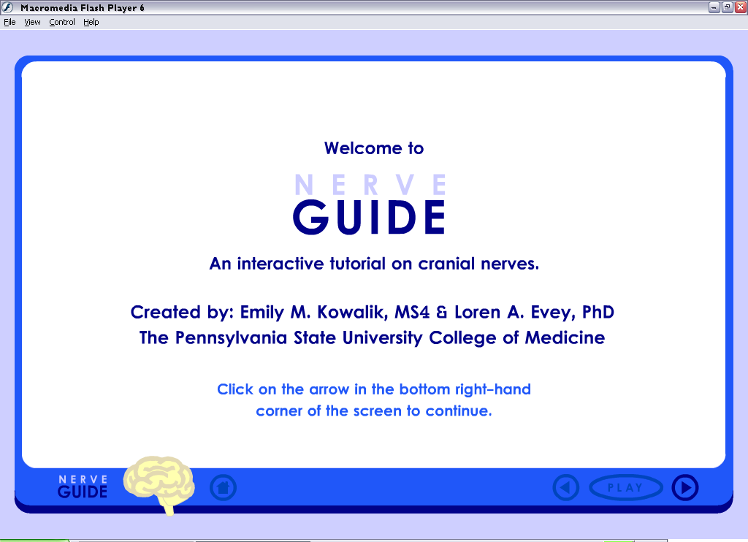

Figure 1. A screen shot from the tutorial. This is the opening page for both tutorials.
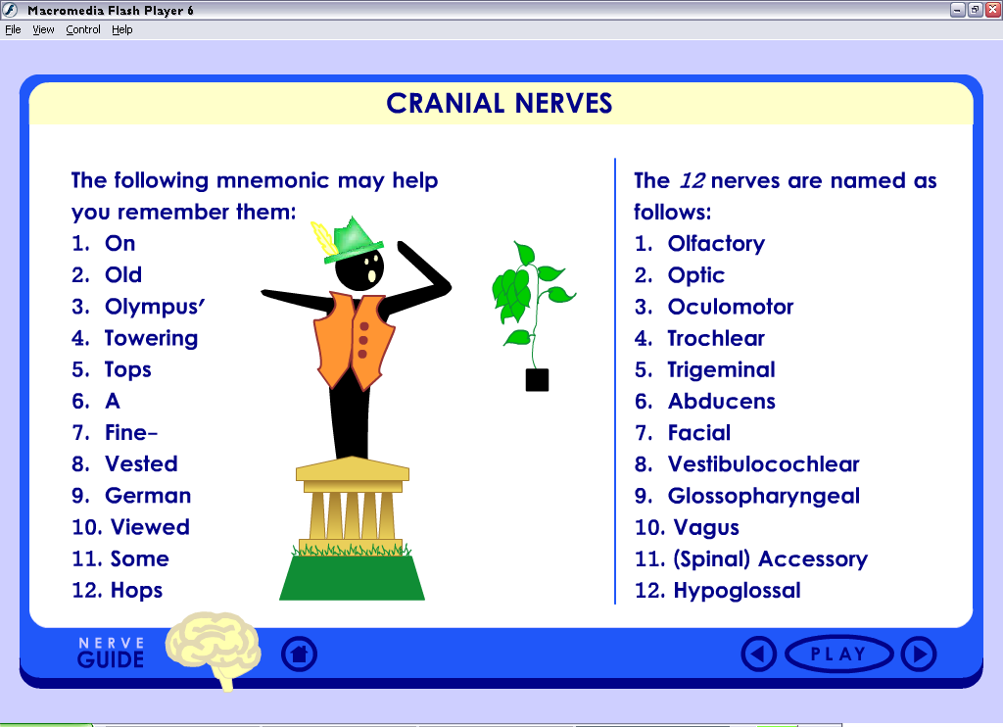

Figure 2. A screen shot from the tutorial. This interactive page lists the names and the corresponding numbers given to each cranial nerve. In the Animated Tutorial, the course of events is as follows: (1) each word in the mnemonic slowly appears, one right after the other and (2) the parts of the image come into view as the corresponding word in the mnemonic appears.
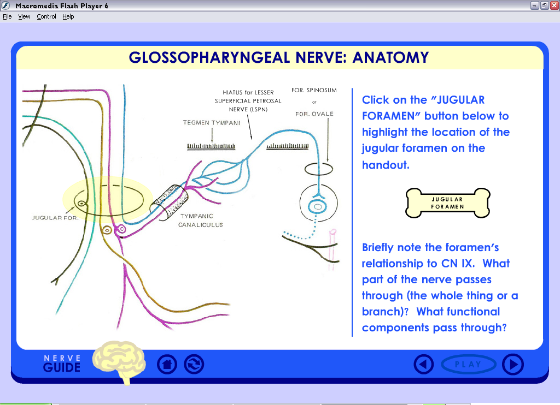

Figure 3. A screen shot from the tutorial. This interactive page describes a portion of the gross anatomy of the Glossopharyngeal Nerve. In the Animated Tutorial, the course of events is as follows: (1) when the students clicks on the bone-shaped “Jugular Foramen” button, a large highlighted area appears over the general region of the Jugular Foramen in the nerve diagram and (2) the highlighted region shrinks in size to focus the student on the specific location of the Jugular Foramen.

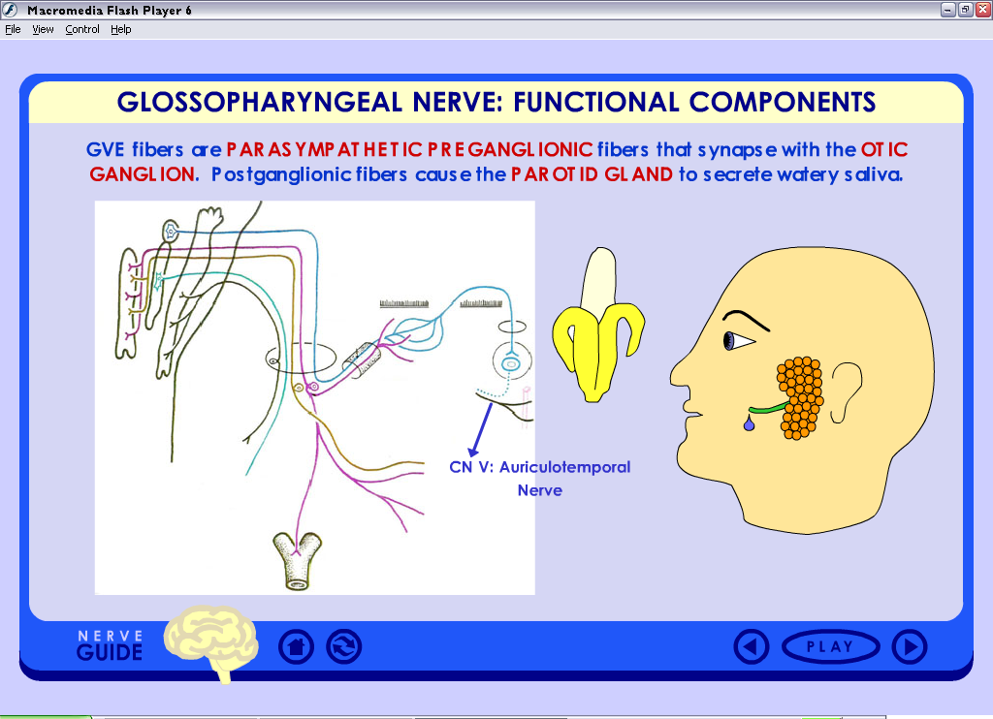

Figure 4. A screen shot from the tutorial. This interactive page describes one of the functional components of the Glossopharyngeal Nerve. In the Animated Tutorial, the course of events is as follows: (1) the banana fades into view, (2) the man’s eyebrow raises, (3) a signal travels down the “blue” functional component (from the spinal cord to the Auriculotemporal Nerve) on the nerve diagram, and (4) a drop of saliva is secreted from the man’s parotid gland. Note the background color of the tutorial interface has changed to blue on this page; this was to help the students better associate the “blue” functional component with parotid gland secretions.
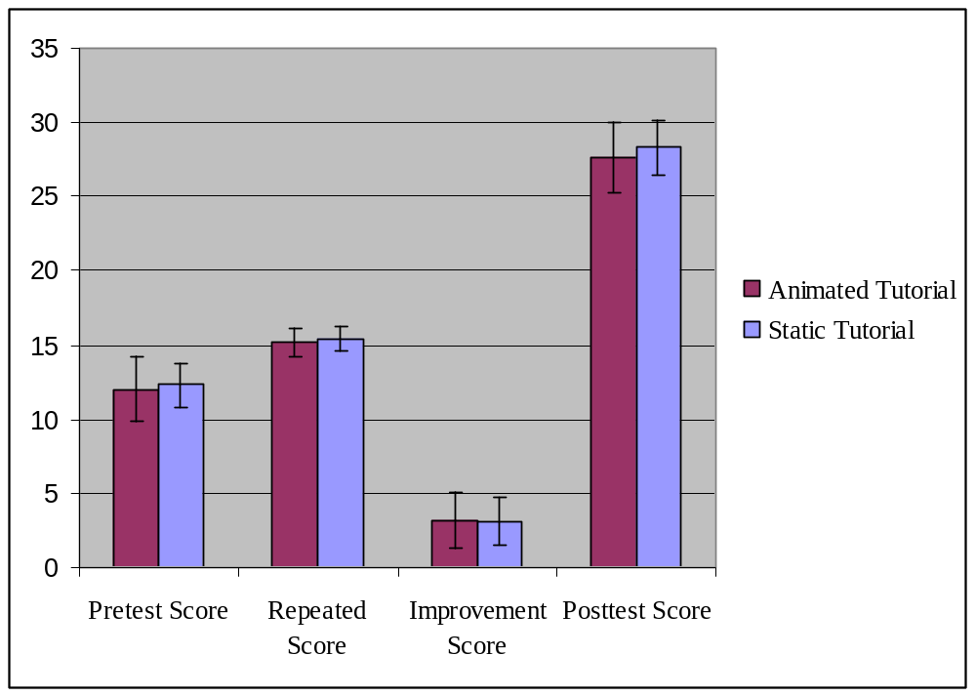
Tutorial Type:
Figure 5. Pretest, repeated, improvement, and posttest scores by tutorial type.
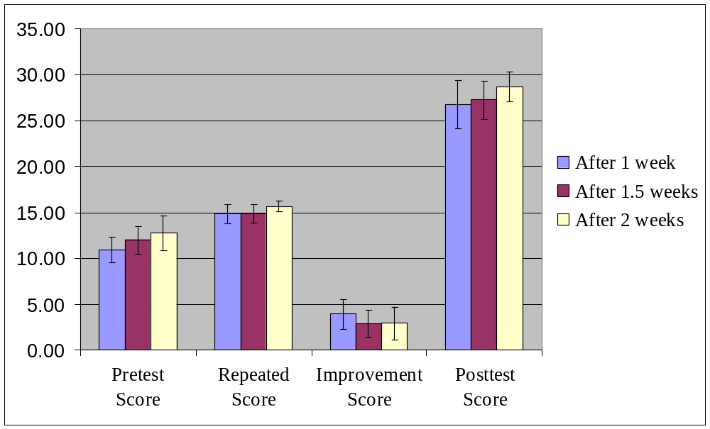

Figure 6. Pretest, repeated, improvement, and posttest scores by time when the students took the tutorial relative to the start of the fourth and final “block” of Human Gross Anatomy.
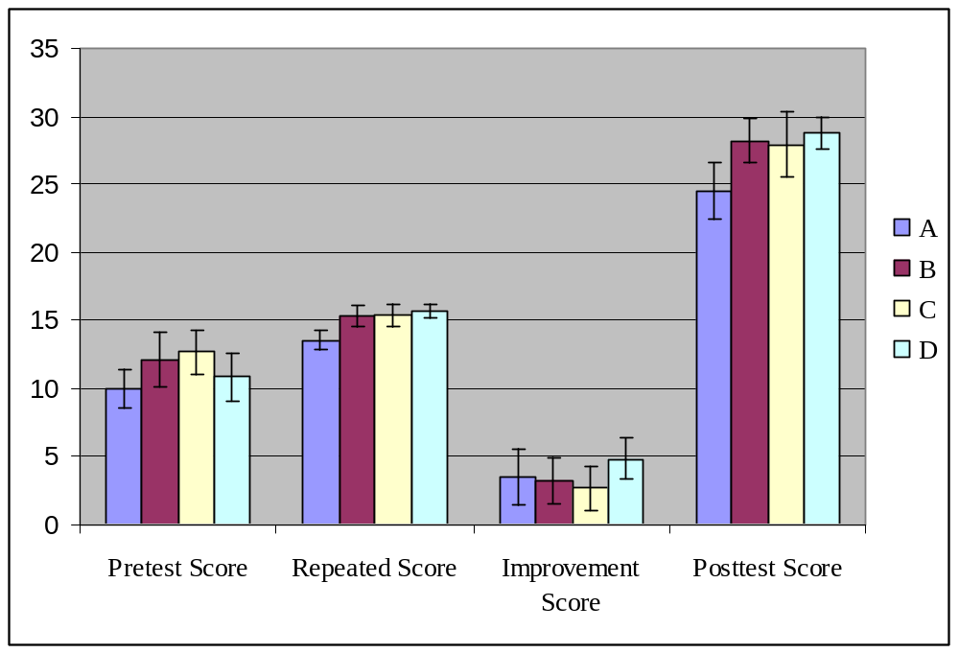

Figure 7. Pretest, repeated, improvement, and posttest scores by subjective learning difficulty. Students selected a letter in response to the question, “For me, mastering information in anatomy is…”, and the letters stood for: (A) easy with minimal effort; (B) somewhat easy with lots of effort; (C) somewhat challenging with lots of effort; and (D) extremely difficult even with lots of effort.

Appendix
Student Comments

Tutorial Completed | Comments
A | Great job!
A | Including sound would be great. Multimodality helps you remember it even better. Thanks!
A | The color that highlighted bony landmarks, etc. was difficult to see
S | Very helpful/complete
S | It was slow. Too many buttons to push. Just show the information on the page. I did like the highlight buttons.
S | There are some minor spelling errors here and there. Visualizations of nerve branches once it exits the jugular foramen could help put things in visual context.
S | This was a very helpful tutorial overall. Though I’m sure I missed a few questions on the Post-test, going over the tutorial 1-2 more times should definitely enforce this information in my mind, and thus would be very useful to have access to.
A | Maybe a brief overview of the specific ganglions where synapsing occurs (like otic ganglion) would be helpful.
S | I have taken the tutorial for the facial nerve available on the Wiki Site. I believe that you were investigating the benefits of animation vs. static images. I think that the animation is much more helpful, although I took the static version of the CNIX tutorial. Thank you for creating this though. Very helpful.
A | Big help because it broke the material down and provided the necessary basics rather than sifting through a huge textbook.
A | Good job!
A | Consider adding slides where the student has to choose the answer to a question (perhaps by “clicking” on the correct answer). The more interactive, the better!
S | I wish there were tutorials for all of the cranial nerves. This was very helpful and let me learn the material at my own pace.
S | During the tutorial, leaving the functional component color key on each picture would be helpful if one does not have the color codes memorized.
S | I really liked it! Well organized and simple while still providing a lot of information.
S | You rock.
S | Excellent overview. Enjoyed it. I enjoyed “static” in that it allowed me to take notes.
A | I enjoyed the tutorial! My only suggestions would be: (1) periodic quizzes in the  tutorial (like the post-test questions, but presented at the end of each section), (2) slightly more emphasis on the named nerves and their branching order/pathways, (3) the pictures of the foramina were not extremely helpful in visualizing the pathways. Thanks!
A | Thank you so much for doing this. It was extremely helpful and very cute. I really appreciate it. We need tutorials like this for all of the nerves.
A | The tutorial helps in learning the basics concerning the Glossopharyngeal nerve. Thanks!
S | All nerves please. Some parts were missing like: tonsilar branch, middle constrictor, Eustachian tube…if they were labeled on the handout it would be easier.
S | The tutorial was very helpful because it brought all the relevant information together efficiently. I like having pictures & text together…it saved me a lot of searching through Gray’s & Netter’s trying to figure out what is important. Clicking on the different buttons made it more interactive & helped me remember. I wish we had one of these for all the cranial nerves.
A | Thanks. It was fun.
S | Thanks.
A | I have previously learned some info on CN9, but this was definitely helpful in augmenting that info.
S | This was great!
S | Thank you! This was very helpful!
S | The tutorial was fantastic & I wish we had it for all the cranial nerves.
S | Very clear. A lot of information provided but not overwhelming (like class). Thank you!
A | Thank you! I think adding questions throughout the tutorial would be effective in testing our knowledge!
S | In contrast to other sources of information, I felt this tutorial was well laid out. The material was not scattered, and was concise. It was much easier to study from this than from multiple textbooks or scattered lectures. Thank you!
S | Thanks!

